Ex.No:1b | EDA – DATA SCIENCE FRAMEWORKS (CRISP-DM, SEMMA, KDD)

AIM:
To implement the CRISP-DM (Cross Industry Standard Process for Data Mining) methodology by analyzing a transaction dataset using Python and Pandas.
ALGORITHM:
Step 1: Business Understanding
Define the objective of analyzing the transaction dataset.
Step 2: Data Understanding
Import the dataset and examine its structure, data types, and summary statistics.
Step 3: Data Preparation
Check for missing values, duplicate records, and convert the timestamp column into the appropriate datetime format.
Step 4: Modeling
Perform basic data analysis such as calculating transaction totals, averages, and frequency counts.
Step 5: Evaluation
Evaluate the analysis by interpreting transaction statistics and transaction status distribution.
Step 6: Deployment
Present the analyzed results and insights for reporting and decision-making.
PROGRAM:
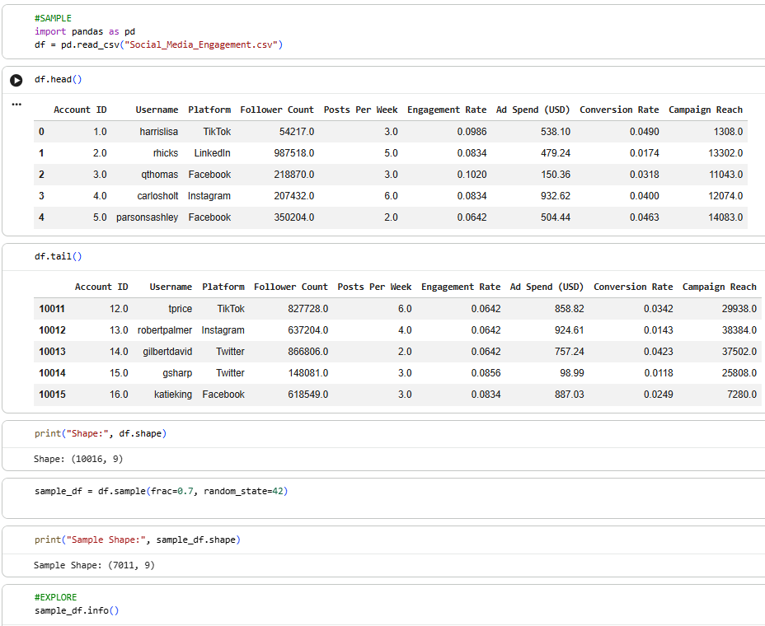
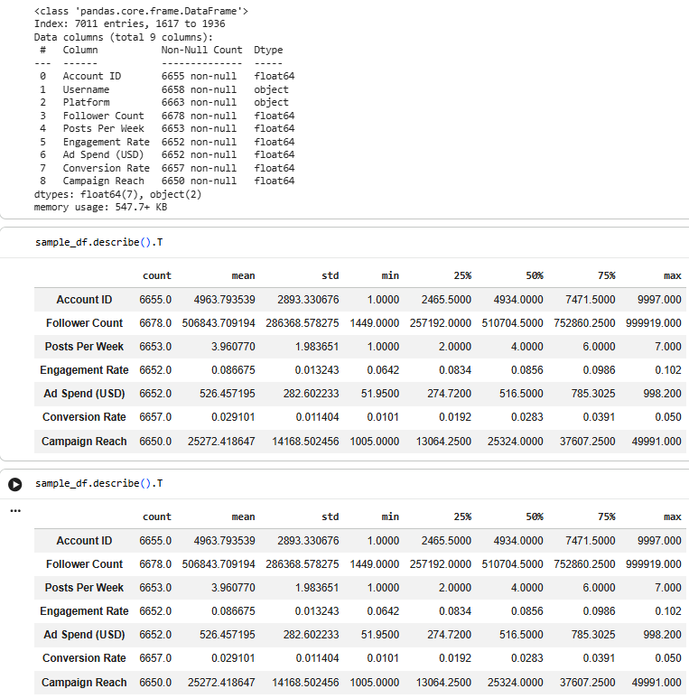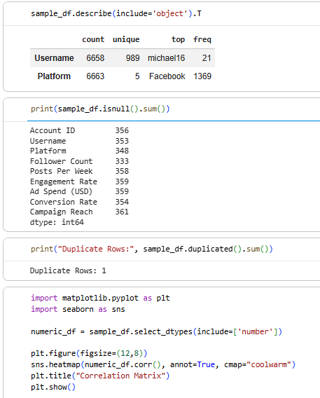

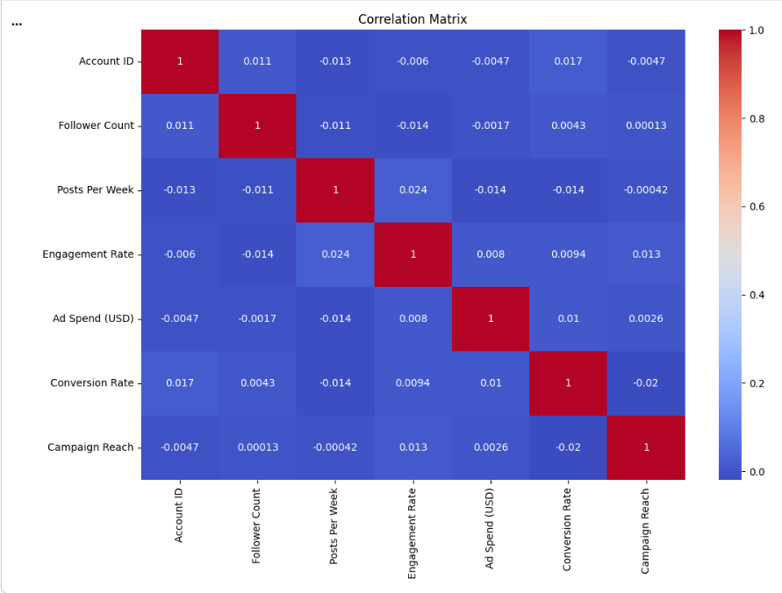
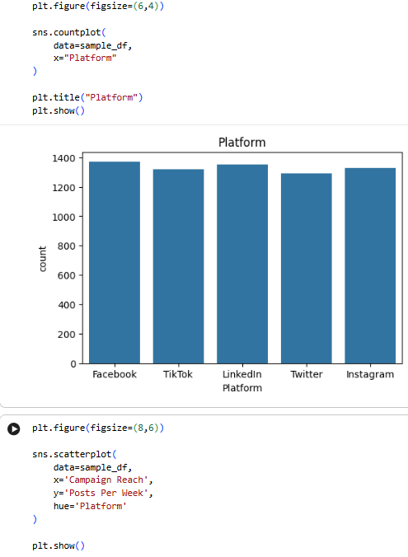
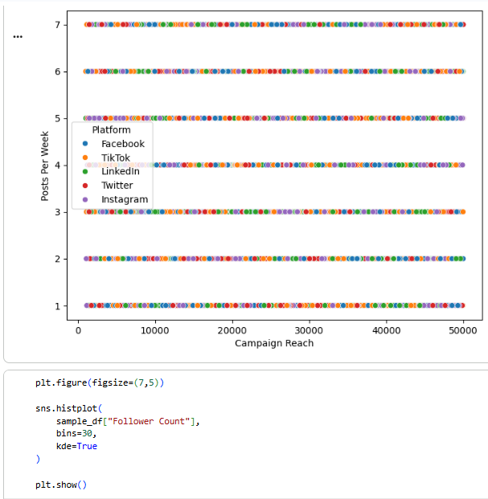
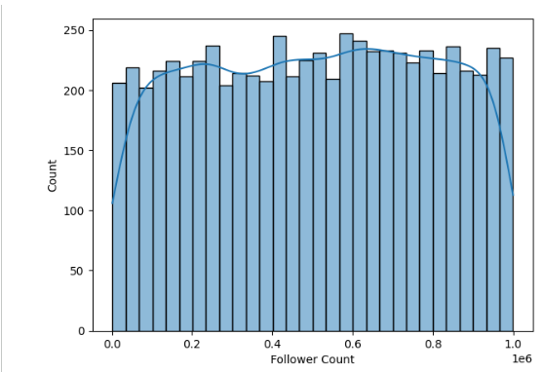

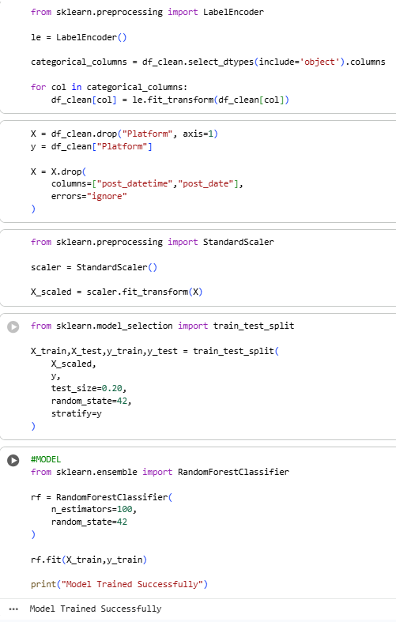

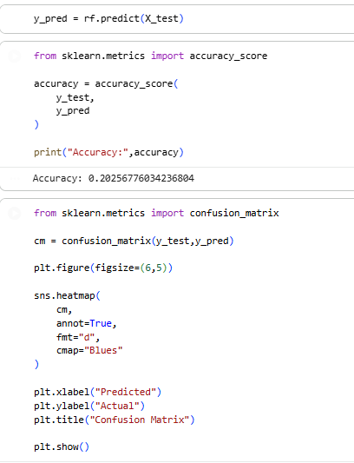
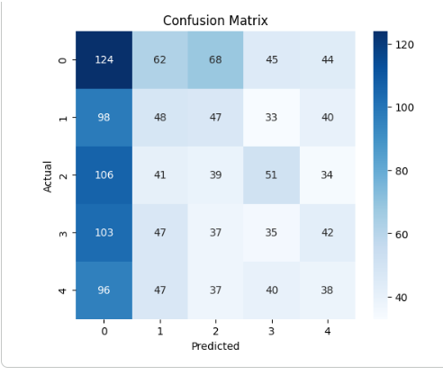

RESULT:
The CRISP-DM methodology was successfully implemented using Python and Pandas to analyze the transaction dataset and obtain meaningful transaction insights.

